**Abstract Floral Large Metal Wall Art**

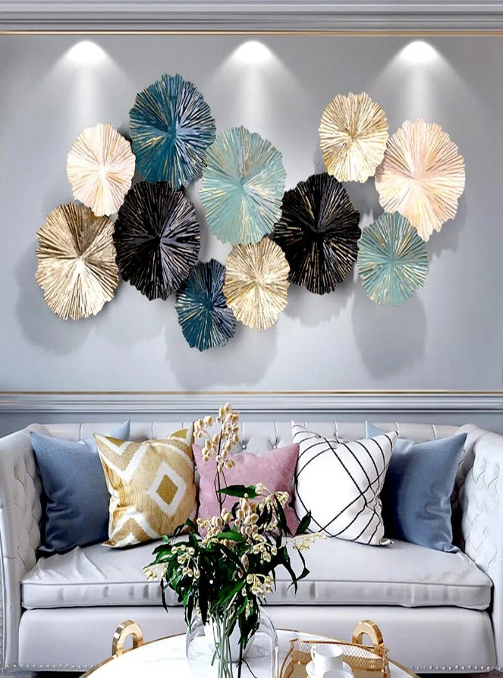Abstract floral large metal wall art is a bold and contemporary interpretation of nature's beauty, offering a dynamic blend of organic forms and artistic abstraction. The piece typically features oversized, stylized floral elements, intricately crafted in metal, with layered textures and flowing shapes that evoke a sense of movement. The metalwork is often enhanced with finishes like brushed silver, gold, or matte black, adding depth and sophistication. Ideal for large spaces such as living rooms, dining rooms, or foyers, this art piece serves as a striking focal point, transforming any wall into a captivating expression of modern artistry and natural elegance.